Conceptual Model

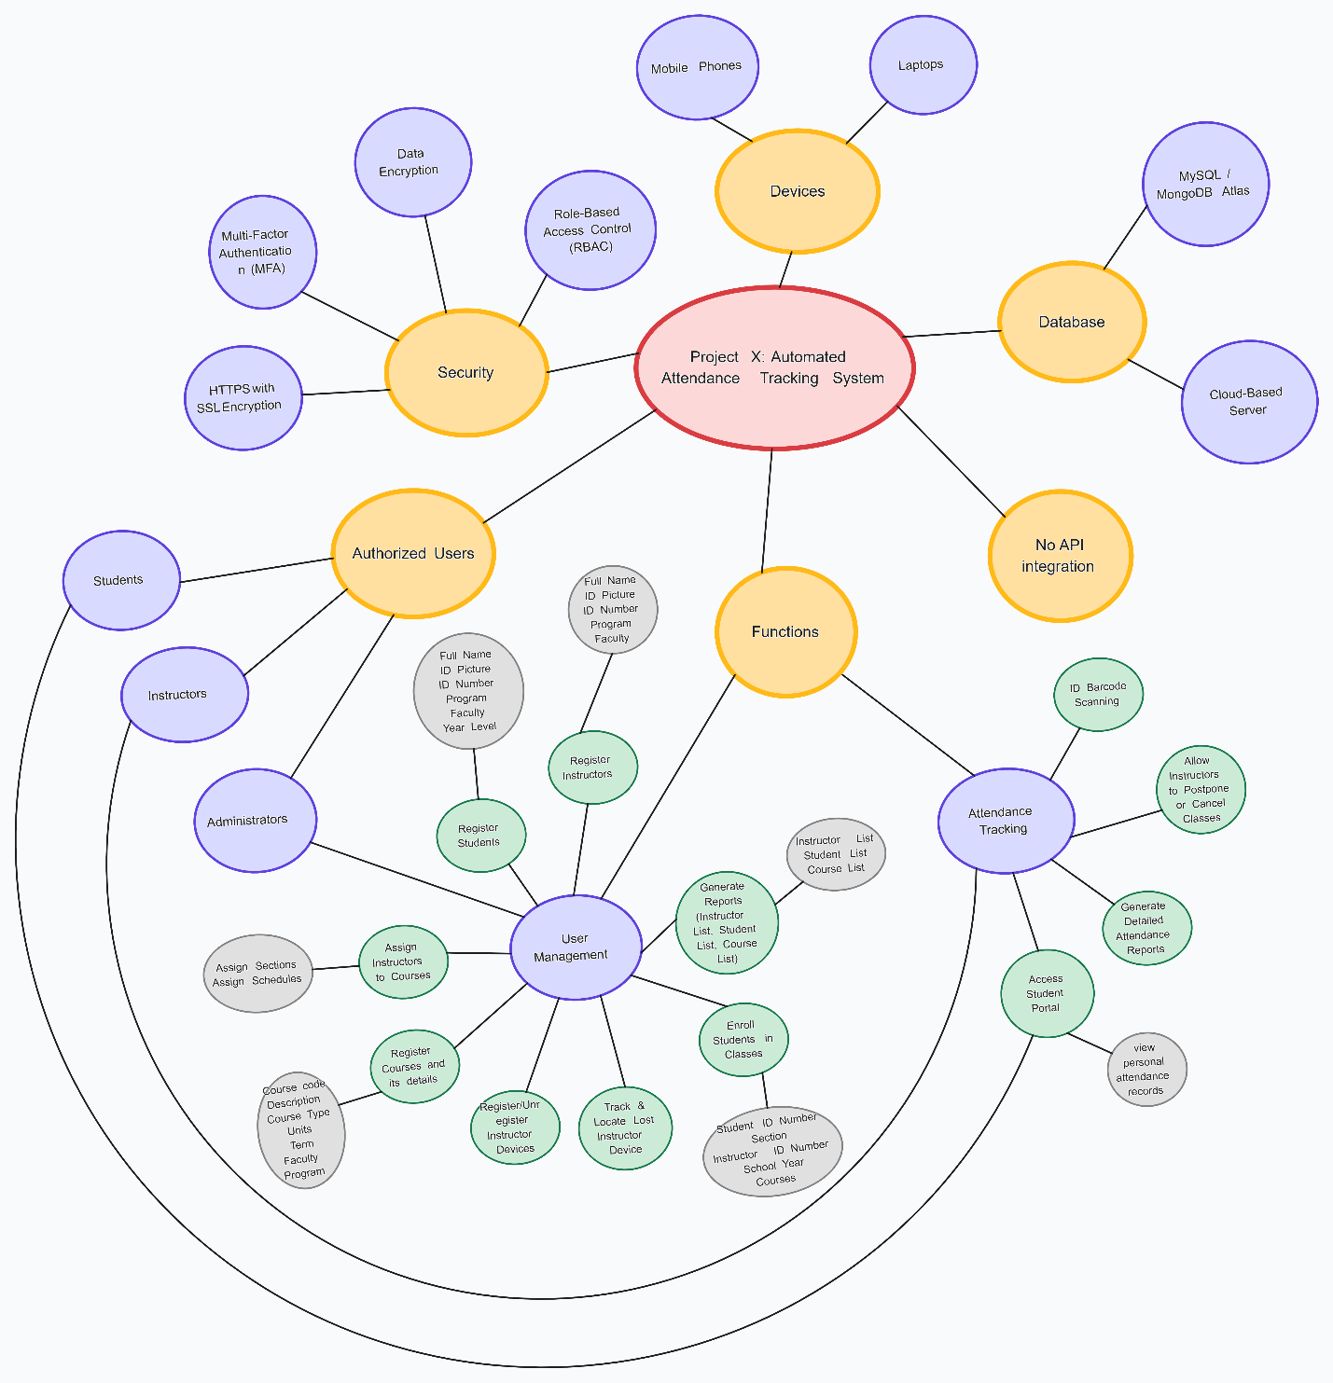Jak of all Trades